First of all, our team would like to congratulate you for your exquisite choice and second, to thank you as well. We hope this new path you have chosen takes you to success. We are glad to be part of it.

Automagick Tube Script is a tool thought to supply a wide range of functionalities and make your life easier. Our ideology is for you to work less and earn more, just by making the right decisions for your business, without the need of taking care of each and every aspect of it.

In this manual you will be presented with an installation guide and the instructions for the first steps with Automagick. You will find it a really simple-to-use script after some recognition of the user interface as every little piece of code, every button and graphic has been designed for you to feel like you already knew the script.

After reading this guide, if you still have questions, you can read our FAQ, in http://www.automagick.com/faq.html (you have to be logged in) or you can also write an email to support@automagick.com

Installation Guide - Updated May, 08th 2013

Once unzipped, the first thing to do is upload all the files to your server. It is important that you upload PHP files in binary mode. This is set in your FTP client (usually, Options -> Transfer Mode, or similar).

When upload finishes, just point your browser to your site (www.yoursite.com).
You should be redirected to the installer (if you are not, probably you hadn’t upload the script in Binary mode).
If you are redirected but you get a white screen, CHMOD ‘admin/libs/smarty/templates_c/’ folder to 777.

Installation Screen:
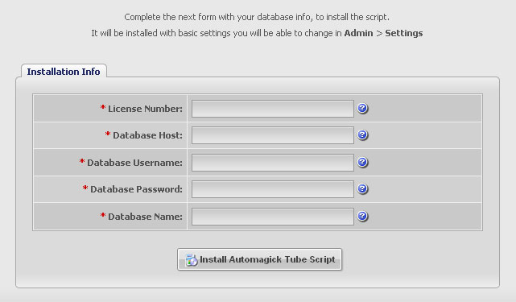

You will have to enter your license number, which you will find in your Automagick.com account, and the database info, you have created for it.
Sometimes, and depending on the server configuration, you will see warning messages, for different reasons:
FFMPEG not installed warning:

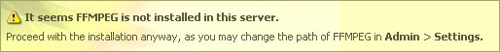

This means the script did not find ffmpeg executable file in neither the two most common places (/usr/bin/ or /usr/local/bin/). It is displayed as a warning just because you can configure later the path of ffmpeg in Settings.
FFMPEG is not mandatory, but you will need it if you would like users to upload videos and to be able to generate thumbnails and preview images automatically and extract the duration of the videos.

Imagemagick not installed warning:

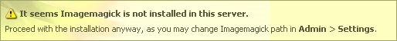

This means the script did not find both the executable imagemagick application: convert, in the most common paths (/usr/bin/ or /usr/local/bin/). It is displayed as a warning just because you can configure later its path in the Settings. Imagemagick is only used to generate thumbnails with a better effect than the created by GD2 Lib.

Folder Permissions Warning:

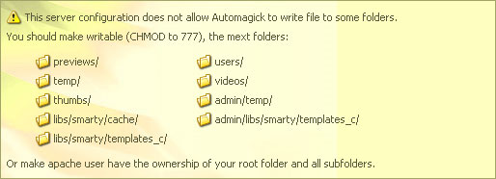

This means that your server doesn’t allow apache (the script) to write to folders (which by default have 755 permissions). You have 2 solutions for this: CHMOD all folders in the list to 777, or installing suPHP for your server or domain (recommended one).
Magic Quotes GPC not enabled error message:

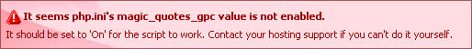

If you get this error, you can’t continue with the installation. This configuration value is mandatory in order for the script to work without problems. If you don’t know how to edit the value of magic_quotes_gpc of your php.ini configuration file, contact your hosting support and ask them to do it for you.

You should probably request them to change other configuration values, named in Automagick.com for the Recommended PHP Configuration:
- safe_mode off
- upload_max_size and post_max_size greater than max video upload size you wish to have.

Check the _php.ini file included that will show you some recommended values for PHP configuration.

Finally, if everything went ok, you should see the next success message:

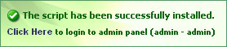

If you click the link (or if you reload the page), you will be presented with the login form, and you will be able to access the admin panel with the default username and password: admin – admin.

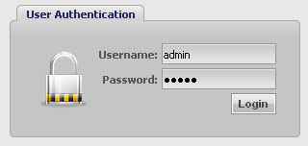

You can now start using Automagick Tube Script. You will find that every option has a tooltip and you will be able to easily understand what it is for.

Skip to next page to a Quick Start guide.
Quick Start Guide

Assuming you have installed the script correctly and been able to login to the admin panel, you are now able to set up the script to your match your project and idea, but before doing so, let’s take a little tour for the main modules of the admin panel.

The menu bar will hold access to all the modules you need to use.

Here is a little description of each, just as a quick reference:

- Videos:
To manage all the video contents of the site: Approved/Listed, Waiting for Approval and Premium videos.
These are separated in different tabs, to keep the contents ordered.

You will be able to manage all aspects of the videos, from its basic data, as the title and description, to the media files, translations and configuration of the specific video. You can also use filters, ordering, searching and other options to work faster and with accuracy.

- Categories
To add, edit and delete categories and groups of category

- Channels
To add, edit and delete channels and its promotional material.
A channel is similar to a category, but it serves a different purpose: to link a “group” of videos with a promotional site.
This will allow you to promote a specific website within all the videos of a channel.

- Sources
To configure and automate the addition of contents.
You may work with mainstream or adult sources.

Important Note: If you would like to use automatic mode of the sources, you should create a cron job, pointing to ‘magick/sources_cron.php’ (Check the CronJobs installation Section,below).

- Users
To manage all registered users and their premium subscriptions.

- Ads
To manage all advertisement spots on the site, including the chance to add multiple banners with assignation of rotation percentage (called weight).

- Templates
To manage the templates and styles of your site, including a template editor, to make minor changes without major difficulty. It is not recommended to use it for big changes.
Also, you will find a showcase of the official templates of Automagick 2, both free and paid ones.

- Extras
This menu holds all the options that are not directly related with the management of the site, like Bug Report and Plugins.

- Settings
To configure the whole site and all its options. It is divided in different tabs.

- Updates
To have your script always up to date. It works automatically, installing all files you need with only 1 click.

- Logout
To logout from admin panel. It is recommended to use it instead of just closing the browser, because it’s the only action that will clean the temp folders.

Setting Up Cron Jobs for Sources Videos and Tasks

There are 3 cron jobs you should set in order for the script to grab videos from sources automatically and to perform pending tasks to videos with assigned tasks. You may add them from you cPanel, or similar tool, or request your server support to do it for you.
All the files to be included as cronjobs are located on ‘magick/’ folder, and they are:

- sources_cron.php (once or twice a day would be ok)
- tasks_cron.php
- clear_cache.php
- tags_archive.php (only if you enable the Tags Archive feature, once a day.)

Setting the times the tasks cron will be ran, will depend on your project idea. If you will allow user uploads without moderation, you should set it to run, for example, every 5 minutes. This will be needed only for when a user uploads a video which extension is not FLV/MP4. If you plan to moderate the video upload, or not allowing User upload, then you can make it run every 2 hours or similar. If you plan to run it manually (there is an option in the admin panel).

Now that the idea is clear, let’s put some examples:

Running Videos Cron Job once and twice a day examples:

0 0 * * * /usr/local/bin/php –q /home/my_username/public_html/magick/sources_cron.php

0 0 0,12 * * /usr/local/bin/php –q /home/my_username/public_html/magick/sources_cron.php

Sometimes the path to PHP can change. If this command doesn’t work, check with your hosting support.

Running Tasks Cron Job every 5 minutes

*/5 * * * * /usr/local/bin/php –q /home/my_username/public_html/magick/tasks_cron.php

Running Tasks Cron Job every 5 minutes WITHOUT Logging its actions

*/5 * * * * /usr/local/bin/php –q /home/my_username/public_html/magick/tasks_cron.php?nolog=1

Using cURL to run cronjobs, and password protecting ‘magick/’ folder.

0 0 * * * /usr/bin/curl -u username:password http://www.mydomain.com/magick/sources_cron.php

Where username and passwords are the ‘.htaccess’ correspondent ones (only if folder is password protected)
Use this tool to create your htaccess/htpasswd files: http://webmaster-toolkit.com/htaccess-generator.shtml
Running Clear Cache cronjob every 10 minutes.

*/10 * * * * /usr/local/bin/php –q /home/my_username/public_html/magick/clear_cache.php
This script will delete old cached files. You don’t need to set it if you don’t use page caching for the script.

Settings Overview

Automagick comes with a default configuration that may or may not be what you need, so let’s take a look to the most important stuff of the Settings Module.
In your admin panel, click on the Settings link of the menu.

You will be presented with 7 tabs for configuration.
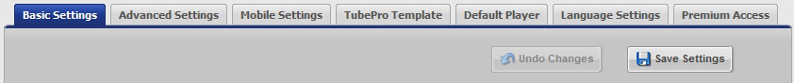

As you can see in the image, there are 2 main buttons. You will be able to undo changes until you save again.

- Basic Settings
Will allow you to manage basic site settings, such as title, thumbs dimensions, etc.

- Advanced Site Settings
Will allow you to control advanced site settings, such as paths to libraries, preferences regarding video uploads, user comments, anonymous rating and comments, etc.

- Mobile Settings
Will allow you manage all aspects related to the mobile template.

- TubePro Template
Will allow you manage all aspects related to TubePro template.

- Default Player
Will allow you to configure all aspects related to the default video player, such as its colors, autoplay option, pre/post-roll ads and streaming method.
The recommended streaming method is pseudo streaming, but it you are willing to set up a streaming server, you have the chance to configure it, using the RTMP option.

- Language Settings
Will allow you to manage all languages of the site, as well as all the labels of the front end.

- Premium Access
Will allow you to configure the built-in payment methods (Paypal, Zombaio, CCBill)

Important Note for Paypal Payments:
You should be aware that if you will run an adult site, paypal does not allow them and might probably disable your paypal account for 180 days. If you run a mainstream site, then you just have to use your own paypal buttons, as the default configuration ones are just sample buttons pointing to paypal’s sandbox.
Videos Module Overview

Just as an introduction, you will be presented here with a little map of the options of the modules video.
When you’ll play with it, you’ll note that every option has a tooltip that guides you through what you need.

Video Options

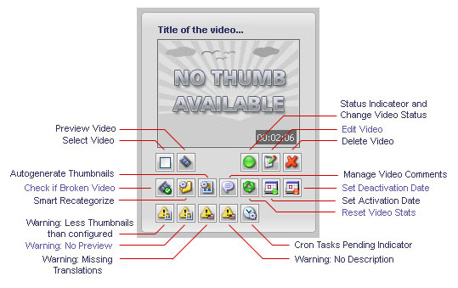

General Options

Not mentioning the filter, search, ordering and pagination options, which will be assumed as trivial knowledge, the main options for working with the videos are, on one hand:

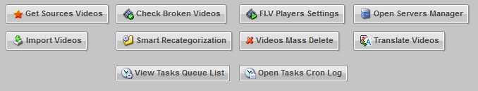

- Get Sources Videos
Will attempt to grab videos from the sources, just as the Sources Cron Job would do it.
It will depend on the configuration of the Sources Module.

- Check Broken Videos
Will check for each and every video in the database for if the video files are working properly.
Sometimes, and especially of some sources, the videos won’t be able to be checked.
This action can also be executed individually for each video.

- FLV Players Settings
Will open a FLV Players manager where you will be able to add your own players.
- Open Servers Manager
Will open a RTMP Servers manager where you will be able to add your own servers and all the related information.

- Import Videos
Will open the videos importer, where you will be able to add videos with several options and methods.

- Smart Recategorization
Will open a little dialog with options to recategorize videos that, for example, have no category assignation.
This is an exclusive feature of Automagick that will make your life easier and your site better.

- Videos Mass Delete
Will open a little dialog with options to mass delete videos.

- Translate Videos
Will add a cron task to ALL videos with, at least, one missing translation.

Actions on Selected Videos

Besides the general options that will be applied to all videos, you will be able to apply certain actions to the videos you select using the select checkbox of each individual video.

They are trivial, and they will be only listed here:

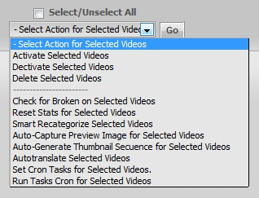

Need Extra Help?

If you need any help or you would like to make suggestions, complaints or any type of comment, don’t hesitate to write to the official support email address: support@automagick.com
You can write directly from your admin panel, by using the Help | Support Option

We will do our best effort to reply as soon as we can, and solve any type of problems.
Automagick Support is the best you will find, as you will always have the right solution to your problems.

